**DMET 1042 Fundamentals of VoIP**

**Project Report**

Our project aims to develop a simple client that can initiate and carry a video call using sip.js by OnSIP.

Our code follows much of the demos presented by OnSIP themselves. It creates a SimpleUser using the simple user interface. This user is registered to OnSIP's own demo domain. The demo currently has a fixed call target which is an account we setup on OnSIP's own app.

Our webpage consists of 6 buttons for call initiation and termination.

1. Connect:

The connect button activates a listener which initiates a connection to the SIP server using the API call .connect()

1. Register User:

This button activates a listener which calls .register() so the user is now registered on the SIP server. If registration is denied for any reason an alert is displayed indicating an error has occurred.

1. Initiate Video Session:

This button sends an SIP INVITE using .call() If the invite is denied for any reason an alert is displayed indicating an error has occurred.

1. End Video Session:

This button calls .hangup() to end the running session.

1. Unregister:

This button calls .unregister() to unregister the created temporary user from the SIP server.

1. Disconnect:

This button calls .disconnect() to disconnect from the demo server.

Our webpage also contains 2 checkboxes to handle mid-call activity

1. Mute:

This check box mutes and unmutes the audio of the call by using the .mute() API call.

1. Hold:

This check box pauses and resumes the call by using the .hold() API call.

Our project succeeds in initiating and holding a video call to an OnSIP account.

Flowchart:

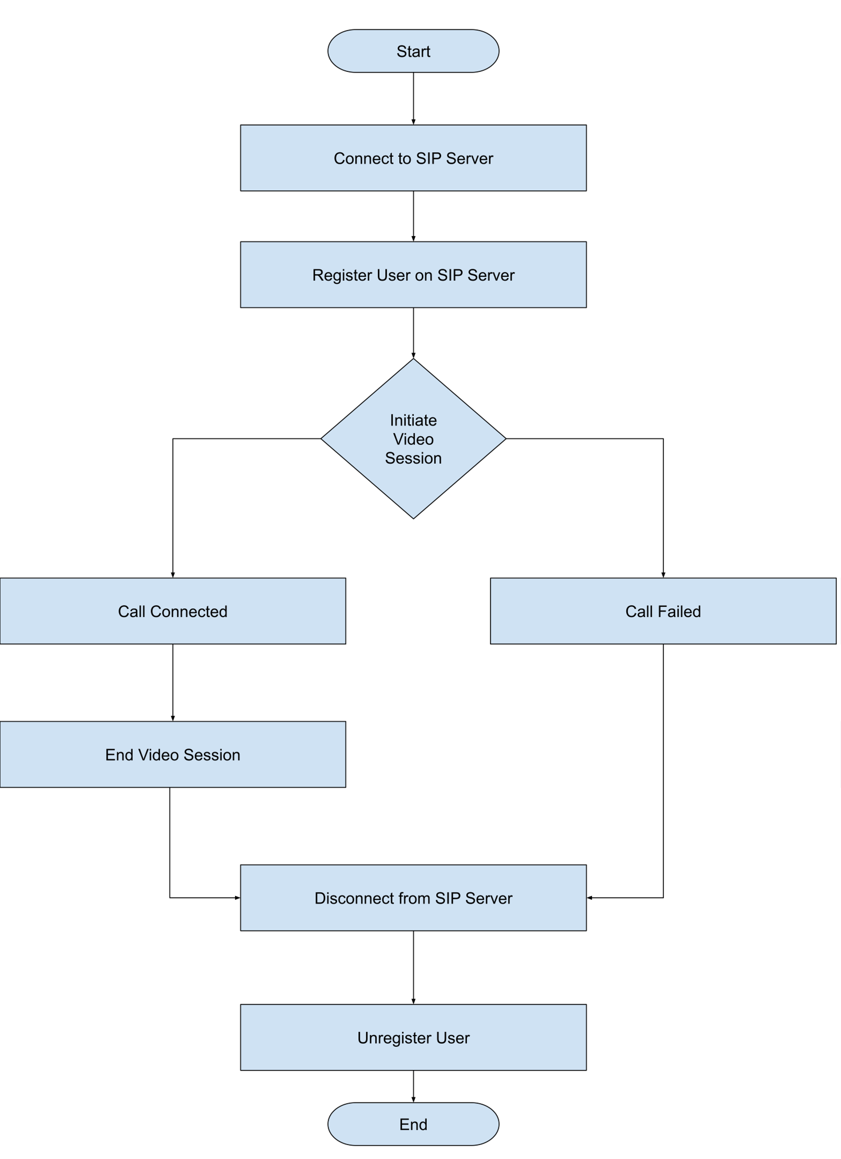

Demo Screenshots:

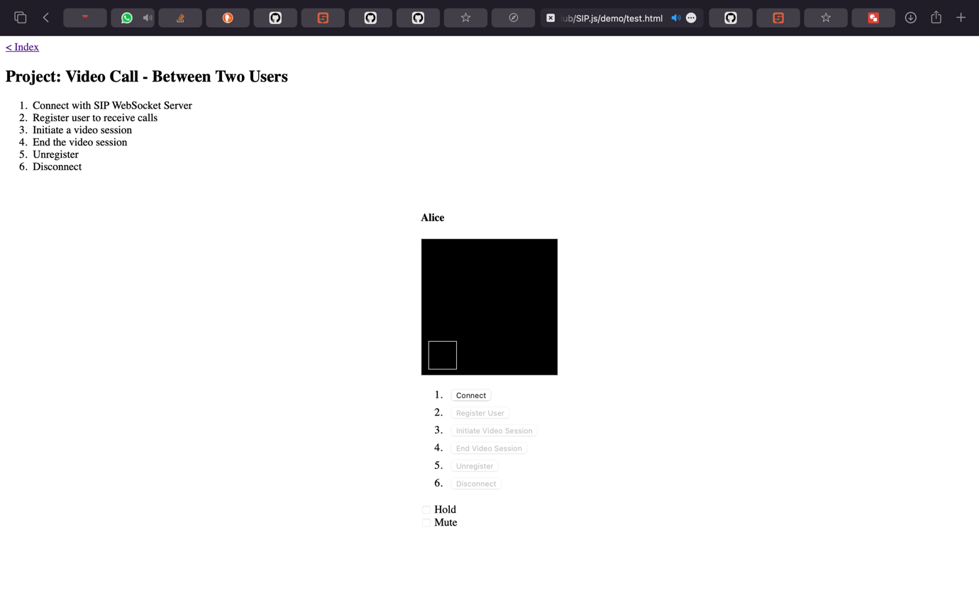

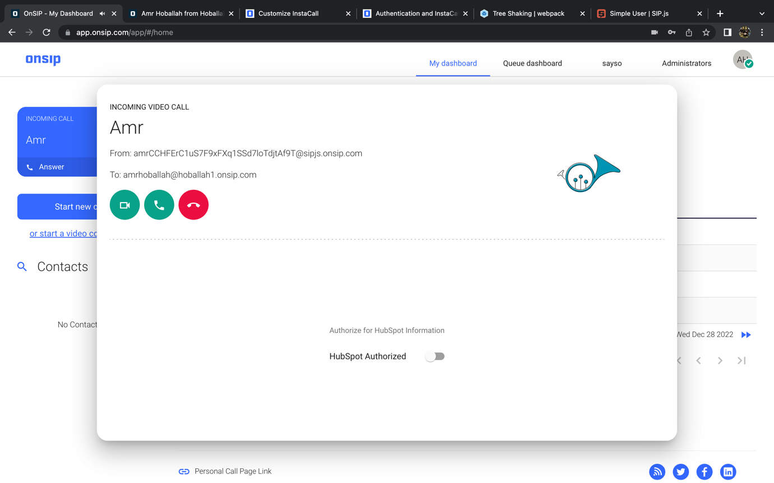

Team:

Amr Hoballah 46-13257

Abdelrahman Sherif 46-

Abdelrahman Badran 46-

No specified contributions as we worked equally on all parts.